LAB 1

Ben Giftakis

2/18/20

Screenshot

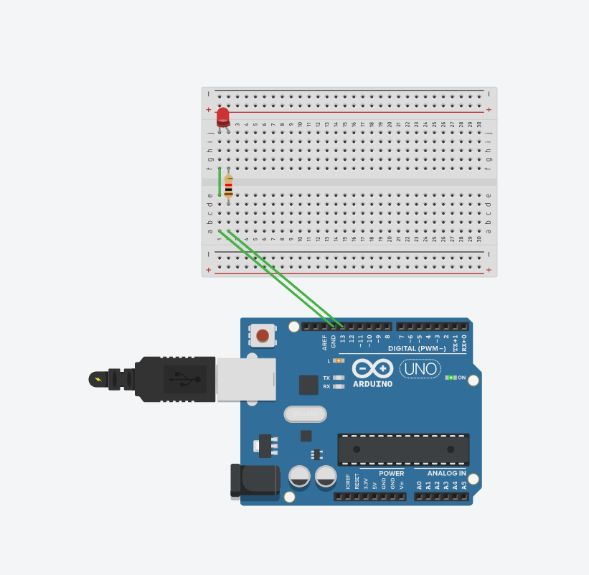

LED - a light that is powered by electricity

Resistor – reduces voltage to the led

Arduino – a computer used to control other devices

Summary:

Created a simple circuit to experiment with Arduino code, electrical components and controlling those electrical components with the arduino’s code. We used the existing template code and modified it to do the lab. We experimented with the serial output, and learned the syntax to send power to the pins on the Arduino.

RESULTS:  
we did not use the serial monitor for this lab  
  
  
CONCLUSIONS:  
Learned how wired work on the breadboard

Learned the interface and controls for the simulator

Learned basic functions in the Arduino language

Learned diodes are one directional

CODE:

void setup()

{

pinMode(13, OUTPUT);

Serial.begin(9600);

Serial.print("hello world");

}

void loop()

{

digitalWrite(13, HIGH);

delay(1000); // Wait for 1000 millisecond(s)

digitalWrite(13, LOW);

delay(1000); // Wait for 1000 millisecond(s)

}